Sai Manoj Gunakala

Web Technologies  
MSIS 517L  
April 18, 2017  
   
 Assignment 8

Screenshots before Minifying:

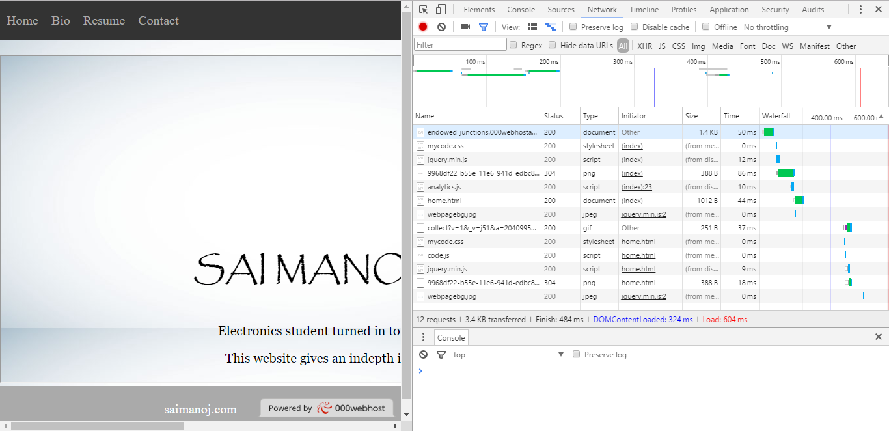

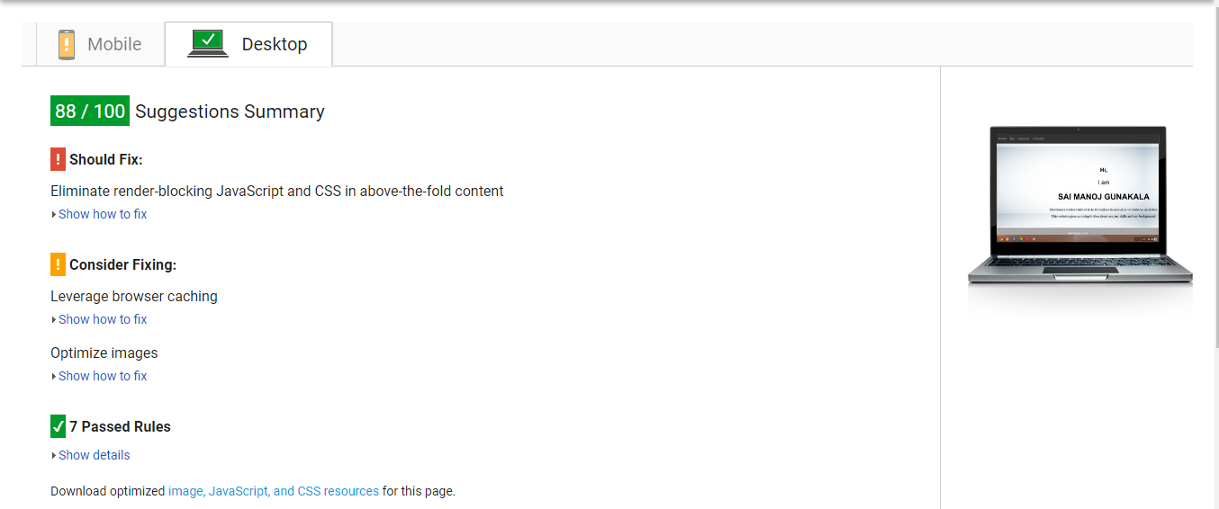

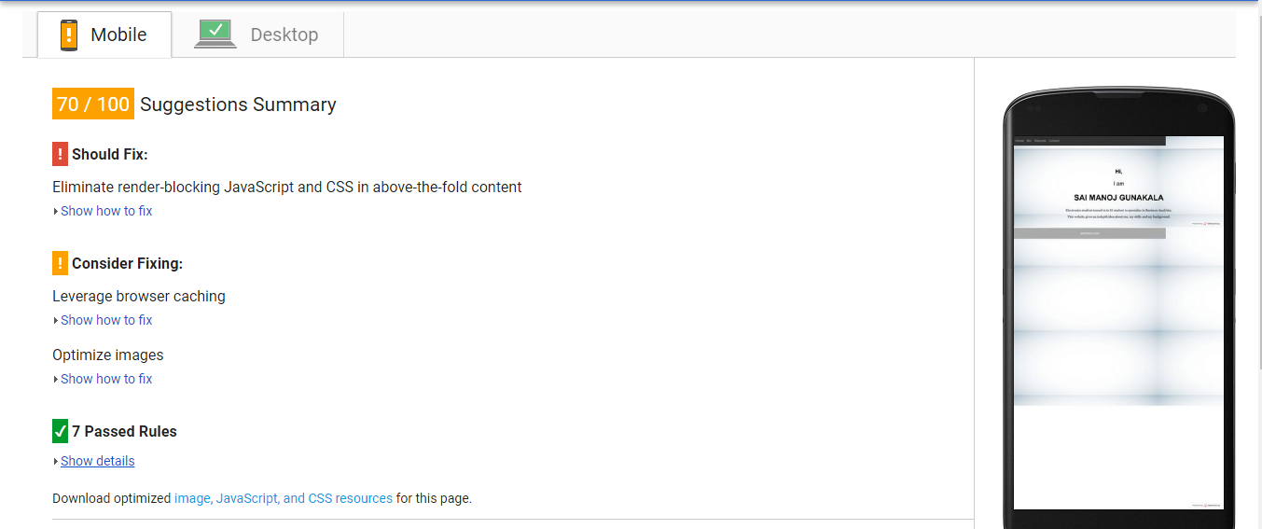

Screen shots after minifying:

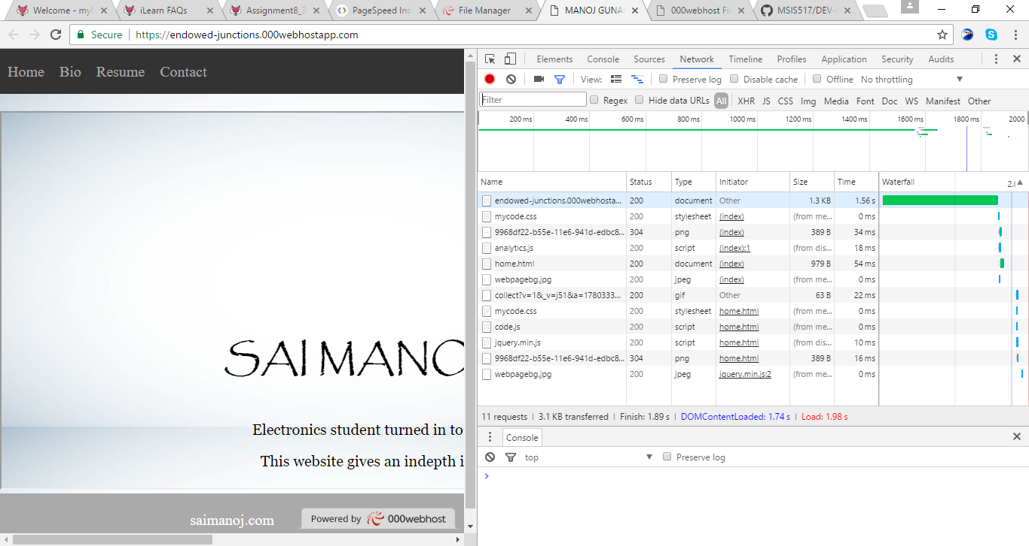

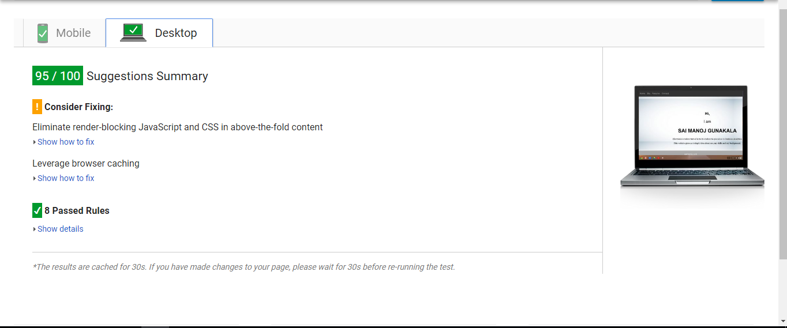

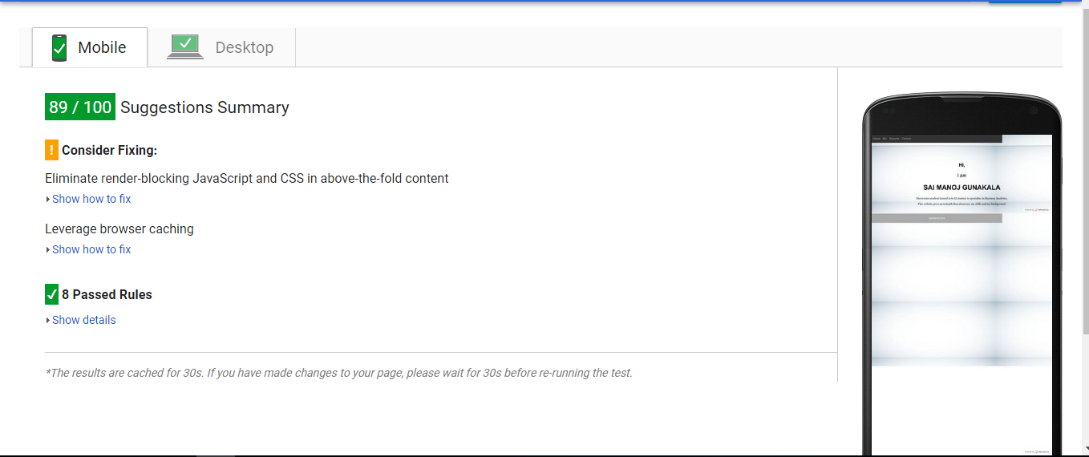

Link: https://endowed-junctions.000webhostapp.com/